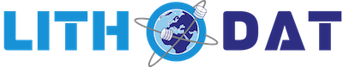

Empowering Saudi Arabia’s Geoscience Future: A Modular Proposal for Data Integration and Innovation

29. March 2025

Proposal Structure
This document outlines Lithodat’s strategic proposal to support the Kingdom of Saudi Arabia in enhancing and modernising its existing geoscience data systems. The following sections present a modular, phased approach designed to complement current efforts and deliver an integrated, scalable, and nationally governed data infrastructure.

1. Executive Summary / Vision
Overview of the opportunity, our alignment with Saudi strategic goals, and the value Lithodat offers.
2. Current Needs and Opportunities in Saudi Geoscience
Key challenges in the current geoscience data landscape and national potential for digital transformation.
3. Our Proposed Solution (general description)
Introduction to Lithodat’s modular service offerings and overall approach.
4. Competitive Advantage
Why Lithodat is uniquely positioned to deliver this solution, including existing clients and technology strengths.
5. Implementation Roadmap
Four-part plan outlining the optional national platform, data adapter, pre-filter, and data mining components.
6. Modular Timeline and Project Streams
Visual Gantt-style timeline showing how each stream can run in parallel or sequentially.
7. Optional Strategic Transition to National Ownership
Pathway to full national control over platform infrastructure, data, and codebase.
8. Path Forward and Strategic Partnership
Next steps, invitation to collaborate, and options for continued engagement.
9. Proposal Status and Disclaimer
Non-binding status, next actions, and offer to formalise through agreement.

Executive Summary

Lithodat is pleased to present this proposal to support the Kingdom of Saudi Arabia in transforming and supercharging its geoscientific data management, integration, and analysis capabilities. Our approach builds on the proven strengths of the LithoSurfer data platform and is fully aligned with Saudi Vision 2030, particularly the Kingdom’s ambition to build a thriving and diversified economy through the sustainable and effective use of its natural resources.
Lithodat is a geoinformatics company specialising in the structuring, integration, and delivery of complex geoscientific datasets. With a robust foundation in research-grade data infrastructure and a strong adherence to FAIR (Findable, Accessible, Interoperable, and Reusable) data principles, we develop and deploy advanced geoscience platforms for government agencies, research institutions, and industry partners worldwide. Our structured data approach ensures that all datasets are provided in an AI-ready format, enabling seamless integration into machine learning algorithms and advanced AI workflows. Lithodat’s solutions consistently enhance data usability, improve accessibility, and ensure long-term digital sustainability across the geosciences, empowering users to derive deeper insights and drive innovation more effectively.
Lithodat's Vision: Empowering Saudi Arabia's Geoscience Future
Lithodat's vision is to empower geoscientists with intuitive, real-time tools to explore, analyse, and optimise natural resource potential, ensuring efficient and sustainable utilisation of their data . This aligns directly with the Kingdom of Saudi Arabia's strategic objectives in resource management and scientific advancement, and the Saudi Geological Survey's (SGS) vision to be a global leader in earth science research, conducting surveys on natural resources, and monitoring geological activities to safe society, and facilitate the Kingdom's efficient utilisation of its natural resources. By providing seamless access to global geoscience data through advanced technology and delivering high-quality geological mapping, structured data solutions, and scientific insights, Lithodat aims to support Saudi Arabia's goals of efficient resource utilisation and leadership in earth sciences. Our commitment is to make specialised geoscience datasets easily accessible and straightforward to use, enabling researchers, industry professionals, and government agencies within Saudi Arabia to unlock the full potential of their geoscience data and contribute to the Kingdom's prosperity and scientific progress.
In our recent meeting with the Saudi Arabia delegation, we had the opportunity to present how our platform could address the challenges currently faced in managing siloed, unstructured, and often inaccessible geoscience data. We understand the strategic importance of developing a robust National Geological Database (NGD) - not just as a repository, but as a dynamic, future-ready system that supports efficient decision-making, enables cross-sector collaboration, and powers innovation.
To this end, we propose a phased approach leveraging our expertise and technology to:
- Standardise and harmonise existing and incoming geoscience data across various formats and sources;
- Act as a pre-filter and data-adapter for standardising all inbound data, ensuring compatibility and seamless integration with the NGD and other national or international systems;
- Future-proof the NGD to accommodate evolving data types and analytical needs;
- Improve the usability, traceability, and analytical power of Saudi Arabia’s mineral resources data holdings.
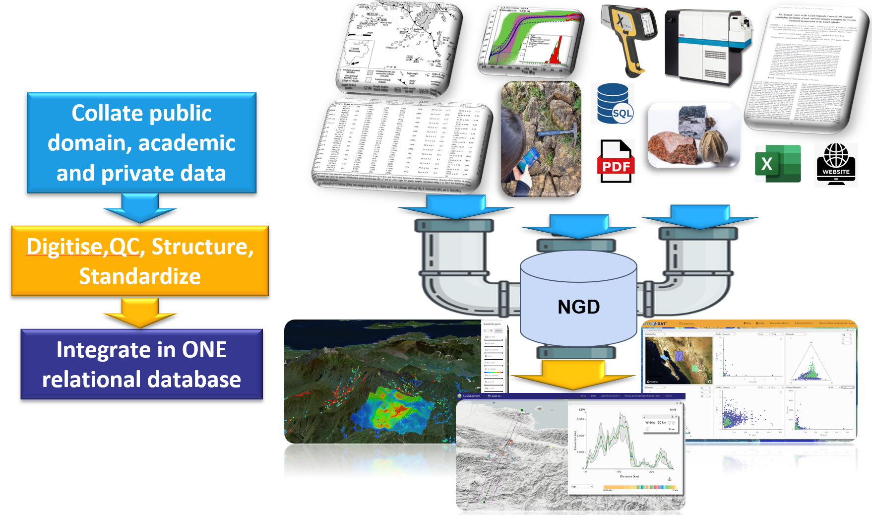
Figure1: Schema illustrating Lithodat’s workflow for de-siloing and standardising multiple geoscience data sources within a unified relational database.
We believe this project represents a unique opportunity to establish a world-class data foundation for the Kingdom’s natural resource sector - one that directly supports the objectives of Saudi Vision 2030 and reinforces Saudi Arabia’s leadership in regional and global geoscience.
A recorded version of the presentation we shared last week can be accessed here, offering a visual walkthrough of our platform's capabilities:
🔗 Watch the presentation
We look forward to continuing this important conversation and working together to shape the future of geoscience data management in the Kingdom.

Current Needs and Opportunities in Saudi Geoscience
Saudi Arabia stands at a strategic juncture in transforming its natural resource sector, with geoscience playing a pivotal role in achieving the goals set by Vision 2030. The Kingdom is rich in mineral resources, with vast potential for exploration, research, and sustainable development. However, unlocking this potential requires more than geological insight-it demands a robust, interoperable, and modern digital data infrastructure.
Key Needs Identified:
- Fragmented and Inaccessible Data: Geoscience data is often scattered across government institutions, universities, and research centres, stored in disconnected formats (e.g. PDFs, Excel sheets, databases, physical samples). This fragmentation limits its usability for exploration and research.
- Limited Data Discoverability and Reuse: Even when data exists, it is often difficult to discover, access, or integrate due to lack of standardisation, metadata, or shared platforms.
- Slow and Manual Workflows: The lack of streamlined ingestion and validation pipelines delays project timelines and reduces the value of existing legacy data.
- Missed Opportunities in AI and Machine Learning: Without clean, harmonised, and well-structured data, Saudi Arabia cannot fully leverage advanced analytical techniques and AI for predictive modelling, targeting, or automated mineral prospectivity.
Opportunities Ahead:
- Leadership in Regional Digital Geoscience: By establishing a national geoscience data platform, Saudi Arabia could position itself as a digital leader in the Middle East and a benchmark for modern data-driven exploration strategies.
- Unlocking Value in Legacy Data: The country holds decades of geoscientific data that, once digitised and harmonised, could deliver substantial return on past investments.
- Institutional Collaboration and Innovation: A unified platform would foster collaboration between institutions, streamline national research and exploration strategies, and enhance workforce readiness.
- Global Interoperability: Aligning with international data standards and practices would enable Saudi datasets to contribute to and benefit from global scientific and industrial collaborations.
Lithodat’s modular platform and services are designed specifically to help countries overcome these barriers and realise these opportunities. The following sections outline how our solutions could support this national transformation.

Our Proposed Solutions
While these three solutions are designed to complement and reinforce each other, they are also fully modular and can be implemented independently. Each component may be undertaken separately or in stages, depending on strategic priorities, available resources, or immediate data management needs. Saudi Arabia may choose to begin with one or two solutions that offer the most value at this stage and expand over time as requirements evolve.
Building on the vision outlined above and our recent discussions with the Saudi Arabian delegation, Lithodat proposes three core solutions as a starting point to support the Kingdom in developing a robust, scalable, and future-ready geoscience data infrastructure. These foundational services are designed not only to meet the immediate operational and strategic needs of the National Geological Database (NGD), but also to enable advanced, long-term capabilities. A key principle across all solutions is the delivery of structured, high-quality data in a format that is inherently AI-ready, allowing for seamless integration into machine learning workflows, predictive modelling, and broader data science applications. By embedding artificial intelligence compatibility from the outset, Lithodat’s approach ensures that Saudi Arabia’s geoscience data infrastructure is fully prepared for emerging technologies and innovation pathways. This vision is fully aligned with the strategic objectives of Saudi Vision 2030, supporting digital transformation, sustainable resource management, and the development of a knowledge-based economy.

Summary of Proposed Solutions

Data Standardisation and Cleansing
A systematic service to establish a scalable, repeatable workflow for standardising, harmonising, and cleansing geoscience data from all internal sources. This ensures that both current and future datasets- regardless of origin or format- can be consistently ingested into the NGD and become immediately usable across other systems and applications.

Specialised Data Mining and Integration
A targeted data mining service to harvest and standardise all publicly available geoscientific datasets ever published on Saudi Arabia, including metadata and raw analytical results, significantly enriching national data holdings.

A National Geoscience Data Portal (Powered by LithoSurfer)
A customised national portal built on LithoSurfer technology, offering an intuitive user interface, advanced analytical tools, and full integration with field data capture and international data standards.

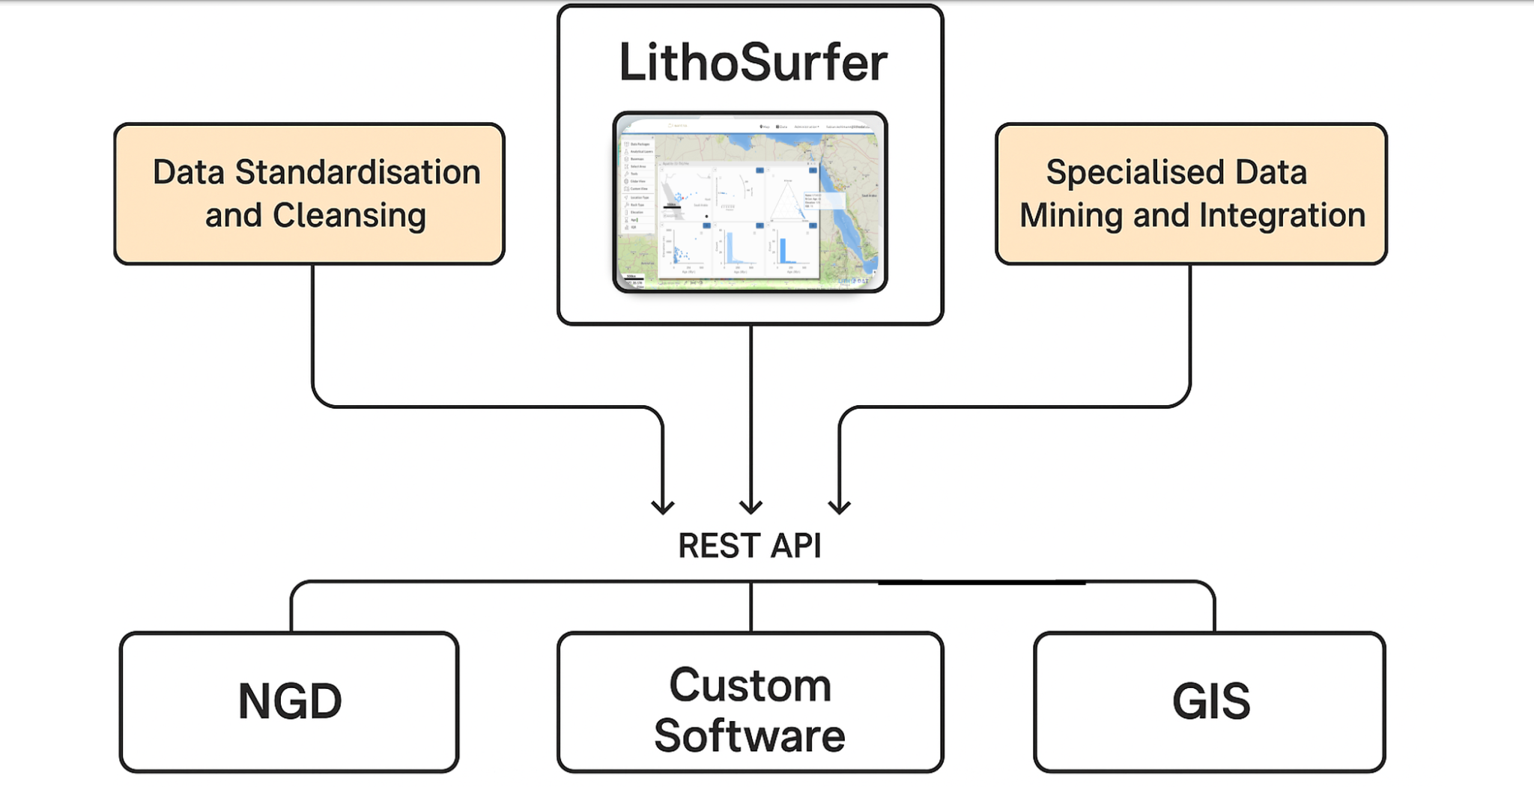Figure 2: Overview of Lithodat’s proposed data solutions to support Saudi Arabia in building a state-of-the-art geoscience data framework.

1. Data Standardisation and Cleansing

Lithodat proposes a comprehensive data standardisation and cleansing solution, specifically designed to prepare geoscientific datasets for seamless integration into Saudi Arabia’s National Geological Database (NGD). This service involves a structured multi-phase approach:

Ingestion: Collection of raw datasets from internal systems, research institutions, and other national stakeholders, regardless of format or structure.

Pre-filtering and Cleaning: Application of quality control procedures, removal of duplicates, correction of geospatial errors, and validation of key metadata.

Adaptation and Harmonisation: Use of custom-built data adaptors to convert each dataset into Lithodat’s global standard model, ensuring interoperability.

Standardisation: Final restructuring of datasets following FAIR (Findable, Accessible, Interoperable, and Reusable) principles to guarantee accessibility and reusability.
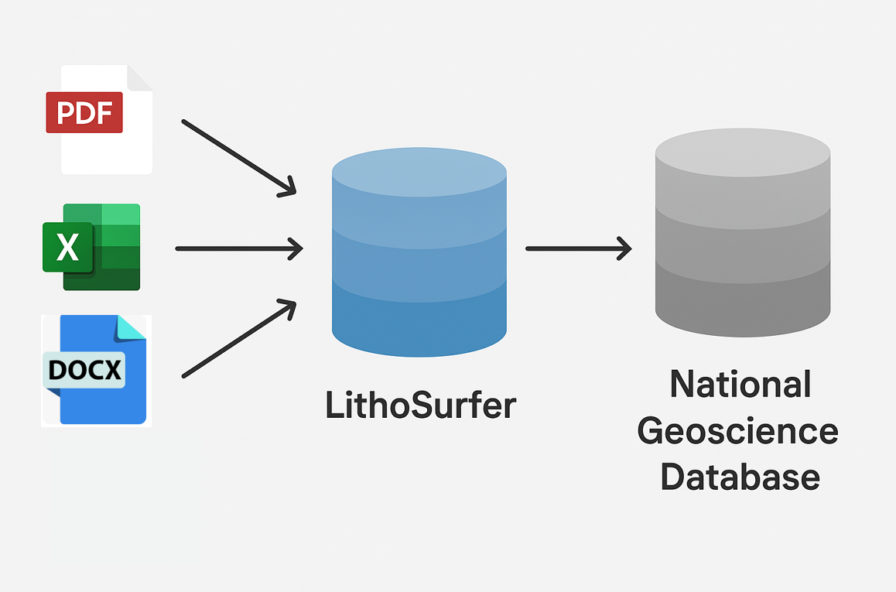Figure 3: Diagram showing how LithoSurfer harmonises diverse data sources into a standardised format with consistent units, enabling structured integration into the National Geoscience Database (NGD).

This process is fully deployed within a secure cloud-based infrastructure, ensuring scalability, version control, and long-term sustainability. Importantly, this is not a one-off data clean-up effort. Rather, it establishes a repeatable, robust workflow and toolset that ensures all future data - regardless of origin or format - can be efficiently standardised, validated, and ingested into the NGD in a consistent manner. Once data resides in this unified and clean environment, it becomes instantly usable across other systems and services, maximising its operational and strategic value. The resulting datasets are not only compliant with international data standards but also structured in a way that enables direct use in AI models and automated analytics. Our interdisciplinary teams of geoscientists, data engineers, and domain experts ensure the scientific and technical precision of each dataset, laying a strong and intelligent foundation for the NGD.

2. Specialised Data Mining and Integration

Lithodat offers a tailored data mining service aimed at systematically identifying, extracting, and integrating all publicly available geoscientific data ever published on the Saudi Arabian landmass. This includes:

Data Sources: Scientific publications, government reports, theses, academic articles, international datasets, and supplemental material.

Analytical Techniques Covered: Uranium-Lead (U-Pb), major and trace element geochemistry, stable isotopes, Ar-Ar, fission track, and (U-Th)/He analyses.

Metadata Extraction: Recovery of analytical details such as laboratories, instruments, run conditions, analytical protocols, and the full range of single-spot and single-grain data.

Data Structuring: Conversion of raw values and text tables into structured, interoperable formats using Lithodat’s proprietary geoscientific data models.

All extracted data is curated into standardised, machine-actionable formats optimised for use in AI applications such as pattern recognition, trend analysis, and predictive exploration modelling. Each dataset is reviewed and validated by subject matter experts in the relevant analytical techniques, ensuring scientific reliability and technical completeness. The mined data will be made accessible via the cloud, fully integrated with the NGD, and ready to support both current operations and future AI-driven innovations.

3. A National Geoscience Data Portal (Powered by LithoSurfer)

Lithodat proposes the development of a fully customised National Geoscience Data Portal for Saudi Arabia, powered by our cloud-based LithoSurfer platform. This portal will be uniquely configured and branded to meet the Kingdom’s strategic and operational needs.

Key features and benefits include:

Custom User Interface: Designed for both internal users at the Saudi Geological Survey and optional public access, providing intuitive navigation and custom dashboards.

On-the-Fly Analytics: Users can query, analyse, and visualise data in real time through map-based tools, cross-sections, time sliders, and statistical modules.

Integrated Plate Reconstructions: Ability to view geological data across different time slices using Lithodat’s built-in tectonic plate reconstruction engine.

IGSN & DOI Minting: Automatic generation of globally recognised unique sample and dataset identifiers, ensuring traceability and data citation.

FieldApp Integration: Field teams can collect and upload data directly into the system via a mobile app, including the assignment of IGSNs during sample acquisition.
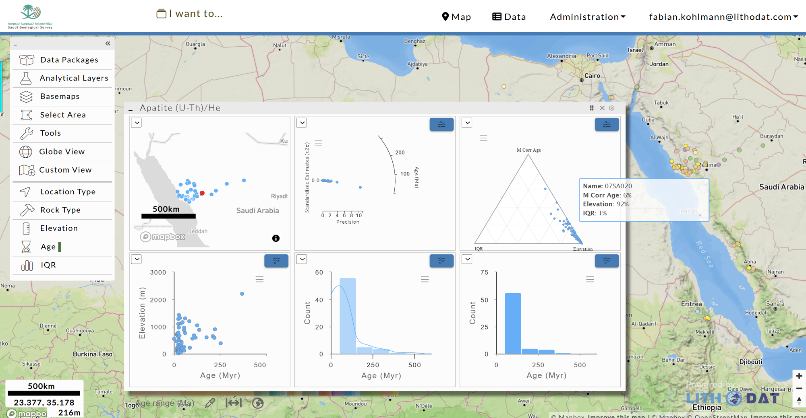Figure 4: Mock-up of a customised browser-based user interface (UI) for the Saudi Geological Survey (SGS), designed to complement and enhance existing data analysis systems.

The portal will also provide seamless access to structured, AI-ready data, enabling integration with Saudi Arabia’s broader AI and data science strategies. All components are hosted on a secure, scalable cloud environment, supporting collaboration, transparency, and cross-sector innovation across the Kingdom’s geoscientific landscape.

These three solutions form the foundation of our proposed collaboration and represent a comprehensive and future-proof starting point for building a national geoscience data infrastructure that meets the current and emerging needs of the Kingdom.

Lithodat’s Competitive Advantage
Lithodat delivers a uniquely effective and trusted platform for managing, visualising, and integrating complex geoscientific data. What sets us apart is not just our advanced technology, but the fact that it is already in active use by leading government agencies, research institutions, and major mining companies. This combination of credibility, adaptability, and proven performance positions us as an ideal partner to support Saudi Arabia’s geoscience and mineral exploration ambitions.
1. Trusted by Governments, Surveys, and National Programs
Our solutions are deployed at national scale and serve as critical data infrastructure across Australia. This includes the AusGeochem platform, developed in partnership with Geoscience Australia and the AuScope Geochemistry Network-now rebranded as EarthBank. We also lead the development of Isotopes.au, the Federated Stable Isotopes Data Platform for Australia, in collaboration with CSIRO, ANSTO, NMI, and Geoscience Australia. These platforms handle sensitive, high-resolution geochemical and isotopic datasets and are built with long-term sustainability, security, and interoperability in mind.
2. Chosen by Industry Leaders: BHP and AngloAmerican
In addition to our government partnerships, Lithodat is already working with some of the largest mining companies globally, including BHP and AngloAmerican, who use our platform to access, integrate, and interpret global geochemical and thermochronological datasets. These companies rely on our tools to support exploration in frontier regions and along complex active margins, demonstrating the commercial-grade reliability, security, and analytical depth of our system.
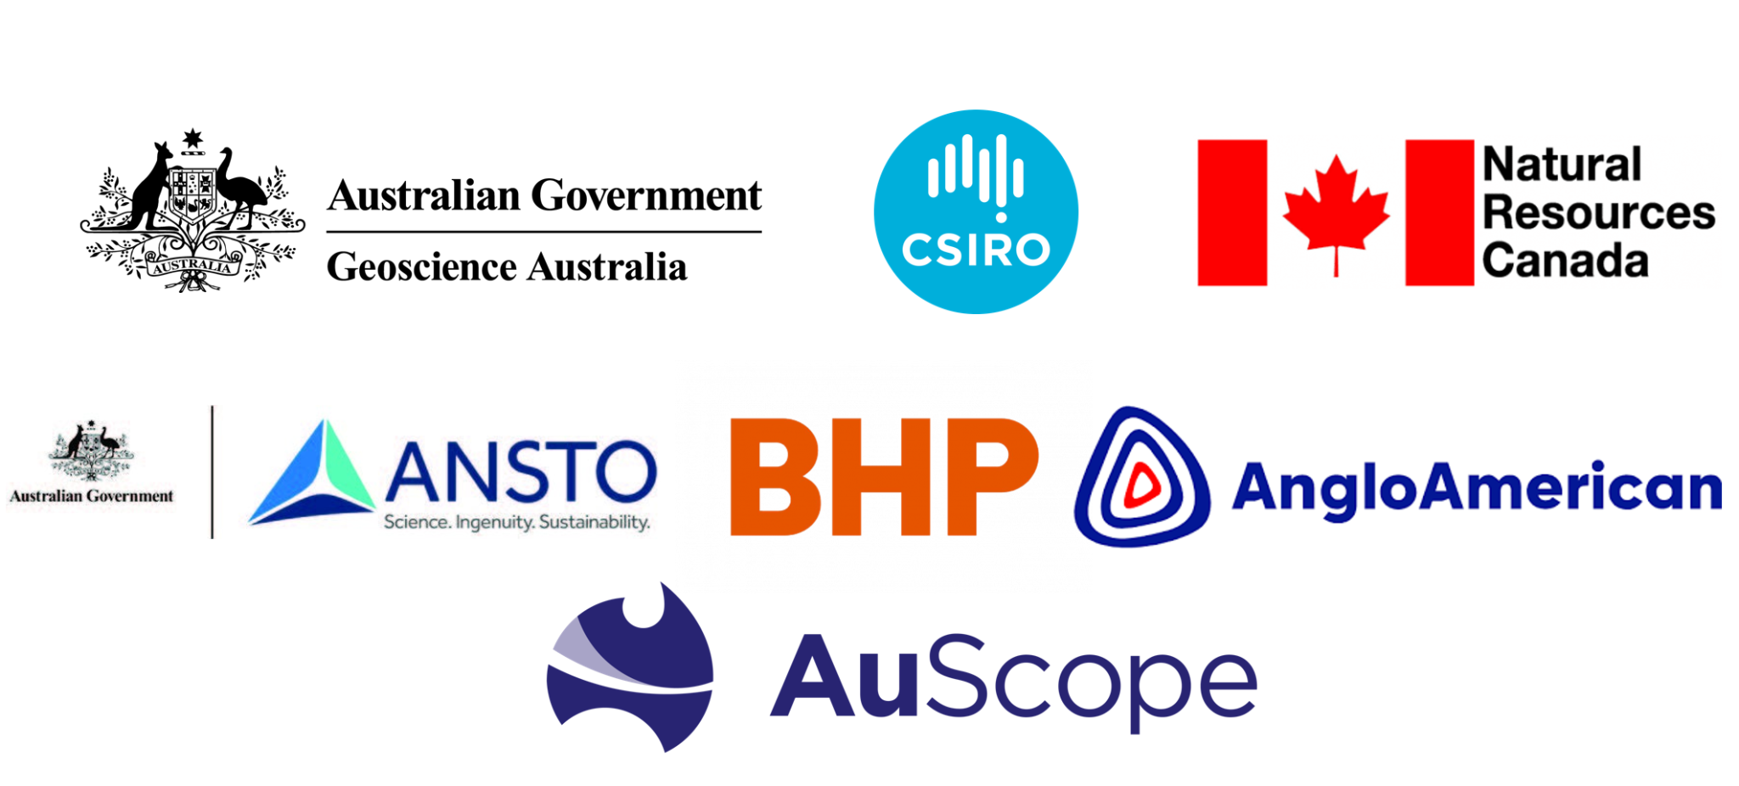
Figure 5: A selection of key government and industry clients currently using Lithodat’s platform and data services.
3. Advanced, Customisable, and Scalable Infrastructure
Lithodat’s platform is cloud-native, browser-based, and fully modular. It supports the ingestion, harmonisation, and querying of spatial, temporal, and analytical data across all scales and formats. Our infrastructure is designed for full adaptability, whether the need is for a national-scale data repository or a targeted project database, allowing rapid deployment with deep customisation to local scientific and operational needs.
4. Built by Experts, for Experts
Our team of geoscientists and software engineers bridges the gap between domain science and modern data architecture. We develop tools that are not only technically advanced but grounded in the realities of exploration and research workflows. We prioritise clean design, intuitive interfaces, and tools that genuinely serve scientific and strategic decision-making.
5. Empowering Local Teams through Collaboration and Training
We work closely with our partners to ensure that local expertise is empowered and elevated. Our collaborative approach includes comprehensive training, knowledge transfer, and long-term support. For Saudi Arabia, this means enabling national ownership of the platform while embedding international best practices, FAIR data principles, and interoperability from the outset.

6. Security, Longevity, and Open Standards
All of our platforms adhere to international standards and best practices, including FAIR data principles (Findable, Accessible, Interoperable, Reusable) and Core Trust Seal certification. We operate within highly secure cloud environments (AWS) and provide full versioning, audit trails, and traceability. Our clients retain ownership and control over all data, while Lithodat ensures that the platform remains dynamic, sustainable, and up to date.
7. A Track Record of Delivery and Innovation
From launching the EarthBank and Isotopes.au platforms to supporting global-scale thermochronology and deposit data integration, Lithodat has delivered critical geoscientific infrastructure for both public and private sectors. Our recent launch of LithoSpace - the first spatial platform for geochemical data from the Moon and Mars, developed together with RMIT and The University of Melbourne - demonstrates our ability to push the frontier of digital geoscience forward.
Implementation Roadmap
Lithodat’s implementation strategy is built to be modular, efficient, and scalable. Each of the four key components offered-, (1) the Saudi Data Adapter, (2) the Data Pre-filter tool, (3) the Data Mining stream and (4) the national LithoSurfer platform - can be delivered and rolled out either independently or in combination, based on priorities defined by Saudi stakeholders. Our roadmap enables early wins through fast deployment of minimum viable products (MVPs), while supporting long-term growth and interoperability.

1. Development of a Saudi Data Adapter
The adapter acts as the integration bridge between existing internal systems (e.g., spreadsheets, local databases) and Lithodat’s data platform. It ensures structured, repeatable, and scalable data ingestion.
- Technical Scoping: Identification of relevant data formats, environments, and access points.
- Adapter Development: Delivery of a customised adapter that can connect to selected datasets and ingest them into the platform in a harmonised format.
- Modular Expansion: The adapter can be extended to new datasets as needed over time.
This component supports the creation of structured, machine-readable data pipelines and can be implemented early in the overall program.

2. Data Pre-filtering Tool for Controlled Visibility
The pre-filtering tool is designed to empower data owners within Saudi Arabia to review, approve, and curate content before it becomes publicly accessible.
- User Role Management: Customisable permissions to allow institutional control over data visibility and editing rights.
- Review Workflows: Tools for marking datasets as public, restricted, or internal-only.
- Integration with Adapter & Portal: Seamlessly works with both the data adapter and the LithoSurfer portal (if implemented), giving full control to national stakeholders.
This component is closely tied to governance and can be delivered alongside or shortly after the adapter.

3. Data Mining and Digitisation Stream
This stream focuses on extracting and digitising valuable legacy geoscience data from a variety of analogue and semi-structured sources. It can operate independently from the platform infrastructure and proceed in parallel.
- Source Identification: Scanning and prioritisation of publications, reports, spreadsheets, PDFs, and scanned maps.
- Digitisation Workflows: Manual or automated extraction of data into structured formats.
- Harmonisation: Conversion of raw content into standardised data structures compatible with the platform.
- Phased Progression: Targeting 2–3 data types per year, with the potential to accelerate based on available resources.
This stream enhances data completeness and utility, especially for AI- and ML-based downstream applications.

4. Deployment of a National LithoSurfer Portal (Optional)
Should Saudi stakeholders choose to establish a national LithoSurfer portal, Lithodat can deliver a fully branded MVP version within 12 months, built upon our existing platform architecture.
- Custom Platform Branding: Includes national URL (e.g., ending in ".gov.sa"), Saudi-specific logo, colour scheme, and styling.
- Hosted Infrastructure: Provision of full backend and frontend components, including web servers, databases, load balancers, automated backups, and user management.
- Initial Dataset Integration: Platform MVP will include support for 2–3 key data types with simple upload or streaming options, ready for immediate use and demonstration.
This step is optional and can be pursued in parallel with or independently from the adapter, pre-filter, and data mining components.
Each of these four streams can operate on its own timeline, with rapid initial development followed by ongoing refinement. This approach supports Saudi Arabia in achieving early deployment, strategic flexibility, and long-term scalability of its national geoscience data infrastructure.

Indicative Timeline

Lithodat’s implementation strategy is modular, agile, and designed for impact from the outset. Each component can progress in parallel, allowing for rapid deployment, early wins, and long-term flexibility. While certain elements (like the adapter and pre-filter) are closely linked, others (like data mining or thematic data stream development) can move independently and be prioritised based on national needs.

1. Data Mining & Digitisation of Legacy Collections
This stream can run largely independently and in parallel to the platform work, focusing on extracting, digitising, and structuring valuable geoscientific content from reports, maps, scanned PDFs, and spreadsheets. All mined data will be harmonised and linked to existing data models for direct import.
- Year 1: Identification and prioritisation of available data sources; establishment of standards and workflows; start of data mining for 2–3 key data types.
- Year 2: Continued digitisation at scale, targeting an additional 2–3 data types; quality control and harmonisation.
- Year 3: Completion of major mining efforts; integration into live platform; optional support for AI-enhanced data extraction.

2. Saudi Data Adapter
The adapter will act as the bridge between existing Saudi data systems (e.g. internal databases, spreadsheets, repositories) and the Lithodat data platform. While this depends on access to existing data holdings, development can begin early and evolve as more systems are reviewed.
- Months 0-3: Technical scoping and consultation with Saudi data custodians to identify connection points and formats.
- Months 4-9: Development of first adapter version; initial tests with selected internal data sources.
- Months 9-18: Extension and refinement of the adapter as more datasets are brought online.

3. Pre-filtering Tool for National Data Governance
This component is designed to allow data owners to control what content becomes publicly visible, and how. It is closely linked to the adapter and platform, and will evolve alongside them.
- Months 6-12: Design and integration of a functional pre-filter into the platform MVP.
- Year 2: Refinement of filtering workflows, custom configuration per institution, inclusion of role-based access, and review workflows.

4. National Platform Deployment & MVP
A minimum viable version of a fully branded, operational Saudi data platform can be delivered within 12 months, based on Lithodat’s existing infrastructure and data models. This MVP would allow immediate integration of selected national datasets and early stakeholder engagement.
- Months 0-6: Platform configuration, branding, hosting setup (browser-based, cloud-native), selection of initial data streams.
- Months 6-12: Integration of 2–3 priority data types (e.g. geochemistry, U-Pb, mineral deposits), user testing, feedback loop, and training sessions.
- Year 2-3: Expansion to additional data types, incorporation of advanced tools (dashboards, analytics, spatial overlays), and support for full national rollout.
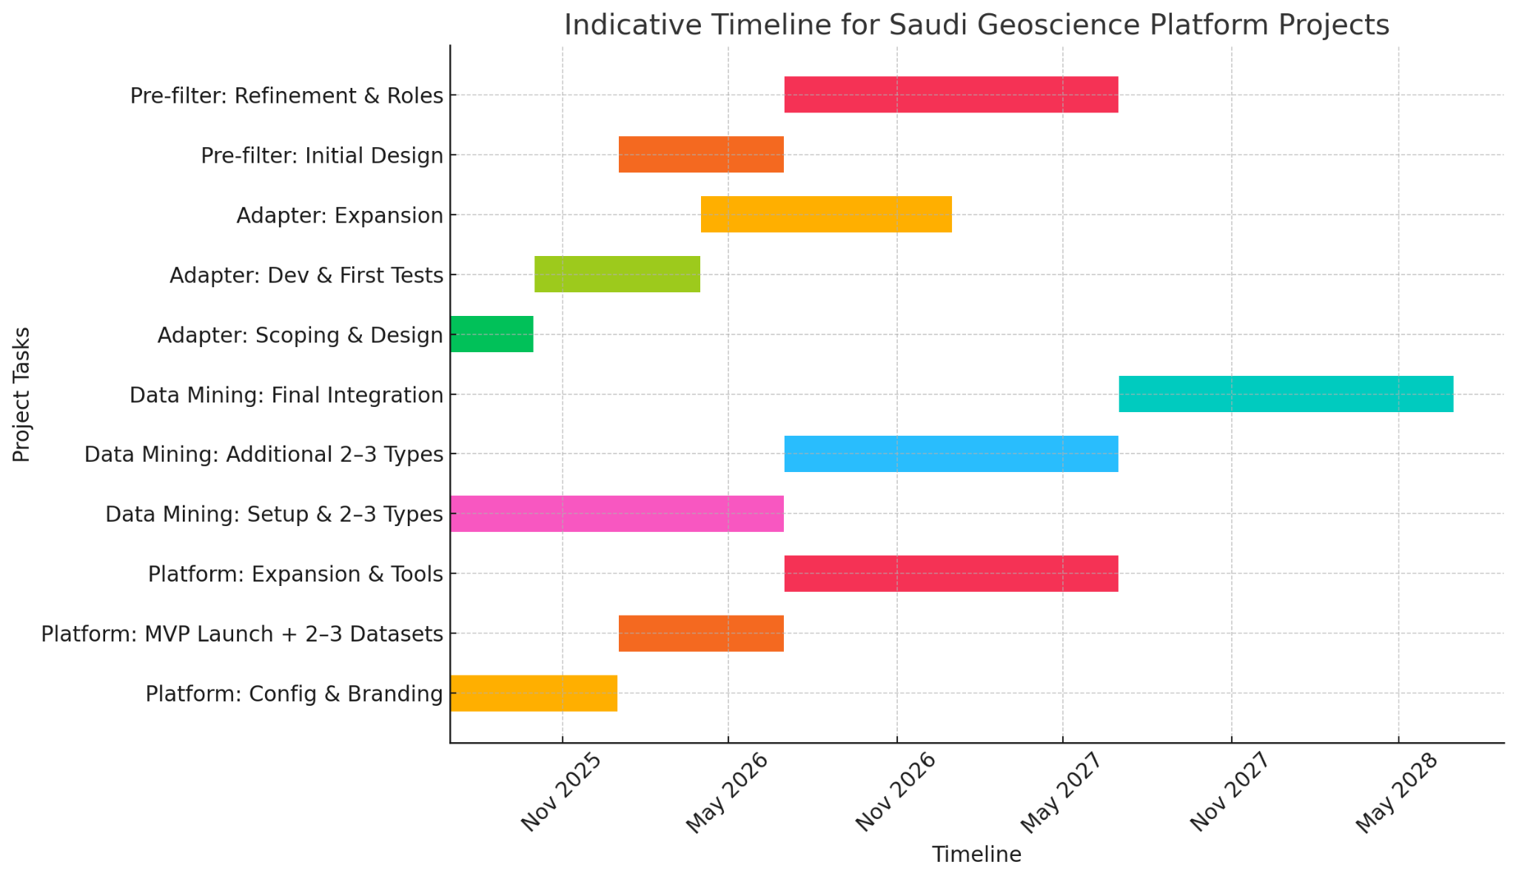
Figure 6: Indicative timeline outlining the phased rollout of Lithodat’s proposed components, including the platform, adapter, pre-filter tool, and data mining stream.
Summary:
While the platform MVP and adapter/pre-filter components are technically connected, they can progress at slightly different speeds and milestones. The data mining stream, however, is largely independent and can be scaled up or down based on available resourcing and priority areas. This approach enables Saudi Arabia to realise a working national platform within the first year, while layering in depth, breadth, and advanced capabilities over the following two years.

Optional Strategic Transition to National Ownership
Recognising the strategic importance of data sovereignty, Lithodat offers a clear pathway for Saudi Arabia to assume full ownership of the platform infrastructure at any stage of the collaboration. This transition includes:
- Migration of the platform and services into Saudi-controlled infrastructure (e.g., a national AWS account or local data centres).
- Full access to the source code and system documentation.
- Legal frameworks that guarantee national control over all hosted data and its management.
- A supported transition phase ensuring technical knowledge transfer and long-term independence.
This option is available upon request and would require a separate agreement and additional cost, as it diverts significant resources from Lithodat’s core operations. In effect, this would constitute the sale of a licensed copy of the platform codebase under a royalty-free, non-transferable, non-exclusive licence strictly for national use. Ongoing updates and support beyond the transition phase would also require a tailored service and maintenance agreement.

Strategic Recommendations for Saudi Arabia
Based on our international experience with government and industry partners, Lithodat recommends several broader actions that could significantly benefit Saudi Arabia’s geoscience and mineral exploration ecosystem. While some of these fall outside our direct service offering, they are complementary to our proposed solutions:
- Establish a National Geoscience Data Strategy: A clear strategy coordinated across ministries, research institutions, and industry would help ensure alignment and prioritisation of national datasets for digitisation, interoperability, and reuse.
- Prioritise High-Impact Datasets for Digitisation: Focus early data mining efforts on datasets that are foundational for exploration-such as mineral occurrences, geochronology, and geochemistry-especially where analogue legacy data remain inaccessible.
- Support for Skills Development and Training: Invest in developing national capacity for digital geoscience workflows, including FAIR data principles, database design, spatial data analysis, and data science for geoscientists.
- Foster Collaboration Between Academia, Government, and Industry: Encourage regular exchanges, co-funded projects, and shared infrastructure between research centres, surveys, and exploration companies to accelerate data use and innovation.
- Engage in International Data Standards and Networks: Actively participate in global data initiatives and adopt open standards to maximise compatibility, visibility, and future collaborations.

Our proposed components-the LithoSurfer platform, data adapter, pre-filtering tool, and data mining stream-can play a central enabling role within this broader strategic framework.

Path Forward and Strategic Partnership
Lithodat is ready to support the Kingdom of Saudi Arabia in building a world-class geoscience data infrastructure that aligns with national ambitions for resource development, innovation, and digital transformation. Our platform and services are proven, adaptable, and scalable - offering immediate value while supporting long-term strategic goals.
We view this not as a one-off project, but as the foundation for a meaningful and enduring partnership. We are committed to co-developing solutions with Saudi institutions, ensuring knowledge transfer, local capacity building, and full national ownership of the resulting system. Together, we can enable a new level of integration, analysis, and application of geoscientific data across exploration, research, and decision-making.
We look forward to continuing our discussions in the coming weeks through further online meetings, and (if there is continued interest) would be delighted to arrange an in-person meeting in Saudi Arabia in late June 2025 to align on next steps and explore a potential pilot or implementation pathway.
We thank you for considering this proposal and remain fully committed to supporting Saudi Arabia’s vision with our expertise, technology, and collaborative approach.

Proposal Status and Disclaimer
This proposal is submitted for discussion purposes only and does not constitute a legally binding commitment unless and until a formal agreement is executed by both parties. The scope, costs, and timelines outlined herein are indicative and subject to change based on further consultation and negotiation.
If desired, a signature block can be provided for acknowledgment of receipt or initial approval to proceed with detailed planning and/or contracting stages.

